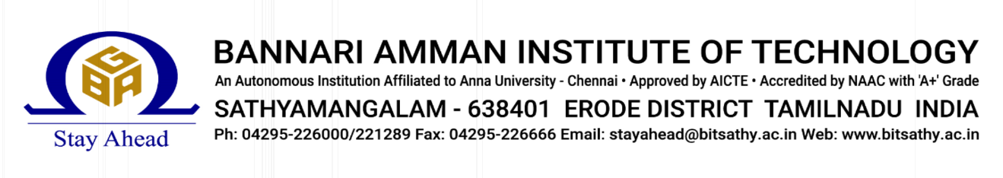

**STUDENT NAME :**  KAVYA M

**STUDENT ROLL NO :**  7376221EC199

**PROJECT ID :** 27

**PROBLEM STATEMENT :**  S8 PROJECT MANAGEMENT

**TECHNICAL COMPONENTS**

| **COMPONENT** | **TECH STACK** |
| --- | --- |
| FRONTEND | React |
| BACKEND | Node.js with Express.js |
| DATABASE | MongoDB |

**PROBLEM STATEMENT :**

The teams are facing problems while registering the form, which includes:

**1. Title Uniqueness:** Students selecting identical topics across multiple teams results in duplicate entries within the system, complicating project management and contributing to a shortage of available titles.

**2. Duplicate Teams:** Multiple registrations with multiple team members lead to redundancy, complicating project management and team allocation, and resulting in the formation of duplicate teams.

**3. Notification Failure:** Delayed communication may result in missed guidance opportunities, potentially affecting project timelines and student support.

**4. Administrative Burden:** Managing registrations and project details demands significant administrative effort, potentially straining resources and complicating time management.

**PROJECT-FLOW:**

**Purpose:**

The purpose of this project is to create project management for S8 students using the MERN stack (MongoDB, Express.js, React, Node.js). The S8 project management system aims to optimize form submission by restricting Google Form access to team heads, ensuring each student receives a unique project title. It automates email notifications to faculty upon form completion and includes administrative controls for managing student and teacher roles. This ensures efficient coordination and communication throughout the project initiation process in an academic setting.

**Scope:**

The scope of this project will develop a web application for Google Form submissions, allowing only team heads access. Admin controls will manage student and teacher roles, ensuring unique project titles and hiding selected topics until form submission. Upon completion, automated email notifications will inform assigned faculty. Key features include user authentication, form management, real-time updates, and email alerts, prioritizing essential functionalities without advanced analytics or third-party integrations initially.

**Business Context:**

This project for Semester 8 project management utilizes the MERN stack. It aims to create a web application where only team heads can access Google Forms, ensuring each student receives a unique project title. Upon form submission, automated email notifications will inform faculty members of their assigned roles, enhancing communication and administrative efficiency within academic project management.

**Consideration:**

**1.**Ensuring a secure and straightforward login process for team heads to access and fill out Google Forms.

**2.**Optimization of automated email notifications for timely communication with faculty upon form completion.

**Dependencies:**

**1.Technology Stack:** Ensure MERN components (MongoDB, Express.js, React.js, Node.js) work together smoothly, leveraging their strengths for robust functionality and performance in the web application.

**2.External APIs :** Verify compatibility and reliable access to third-party services, such as email APIs, to seamlessly integrate automated notifications and other essential functionalities within the project management system.

**User persons:**

**1.**Student: Responsible for leading the project team, filling out Google Forms, and managing project details.

**2.**Faculty Member: Provides guidance and evaluation for student projects, receives notifications about assigned roles and project details via email.

**3.**Admin: Manages user roles, accesses project reports, and oversees the overall functioning of the project management system.

**User stories:**

**1.**As a Student, I want to see only available project titles when filling out the form, so that I don’t select a title already chosen by another team.

**2.**As a Faculty Member, I want to receive automated email notifications upon completion of project submission forms, so that I can promptly review and provide guidance to assigned student teams.

**3.**As an Admin, I want to manage user roles and permissions, so that I can control access and maintain the integrity of the project management system.

**Functional requirements:**

**1.User Authentication:** The system must provide secure login functionality for team heads, faculty members, and admins.

**2.Form Submission :** Team heads must be able to submit the project titles through a Google Form, ensuring each title is unique.

**3.Real-time Updates:** The system must update available project titles in real-time, removing selected titles from the list for other users.

**4.Automated Email Notifications:** Upon form submission, the system must send automated email notifications to the assigned faculty member.

**5.Admin Role Management:** Admins must be able to manage user roles and permissions for team heads, faculty members, and students.

**6.Project Title Validation:** The system must validate that project titles are unique and not duplicated across different teams.

**7.User Interface:** The application must provide an intuitive and user-friendly interface for all users.

**8.Data Security:** The system must ensure the security and privacy of all user data and project information.

**FLOWCHART:**

